  Invention Disclosure Format (IDF)-B | Document No.
 | Issue No/Date
 | Amd. No/Date

1. Title of the Invention
Power-Interruption-Resilient Bulk Tablet Dispenser with Controller-Independent Latched Release Evidence and Start-Up Dose Adjudication
2. Field / Area of Invention
The invention belongs to healthcare technology, within electronic dispensers for solid oral medication at home and in assisted living. It concerns the physical control of a tablet-metering gate by stored dose states and by sensor evidence that is captured in hardware independently of the controller, so that the number of tablets leaving the device, and the record of that event, remain correct when the electricity supply fails.
Missed and doubled doses are common among elderly patients on fixed daily regimens, and people who live alone are the worst placed, since nobody else can say whether the morning tablet was taken. Most low-cost automatic dispensers compare a clock with a stored schedule and drive a motor when the minute matches, a logic that holds only while the supply stays on. A dose whose minute falls inside an outage is skipped without trace, and a restart can repeat a dose because the release flag lived in volatile memory. If the supply fails in the middle of a gate cycle, the device cannot tell whether a tablet left.
Writing a record to non-volatile memory helps only partly. A record written after the gate cycle is absent whenever power fails during the cycle, so the restarted controller releases the dose again. A record written before the cycle claims a release even when the cut came before the tablet fell. A two-phase record written on either side of the release avoids both errors, as the inventors' earlier arrangement showed, yet 41 of 200 supply cuts inside the release cycle still ended with a request for a person to check the tray. The technical problem addressed here is to establish, for a dose whose release cycle was interrupted, whether its tablet left the device, with enough certainty that the dose is neither repeated when it was delivered nor withheld when it was not.
2.1 Technical Problem Addressed by the Invention
- Unresolved interrupted cycles. After a cut inside a release cycle the fate of the tablet is unknown at restart, and conventional dispensers can only guess, repeat the release or refer every such dose to a person.
- Duplicate release after restart. A controller that resolves doubt by repeating the release produces a second tablet whenever the first had in fact been delivered.
- Unnecessary withholding. A controller that resolves doubt by never repeating withholds the dose even in the many cases where the tablet provably never left the pocket.
- False records from sensor misses. A drop sensor that misses a tablet causes a delivered dose to be recorded as not dispensed, which invites a caregiver to give a second tablet.
- Invalid time after interruption. Dose times shift after an outage unless a battery-backed clock is present and its validity is checked, including after loss of the clock's own backup cell.
2.2 Definitions
- Dose ledger (120): a non-volatile record holding one state and its commit time for each scheduled dose, identified by date and dose time.
- Ledger states: RESERVED (a gate cycle is authorised and about to start), CONFIRMED (the tablet was seen crossing the chute), NOT_DETECTED (the dwell ended with the tablet still in the pocket), UNCERTAIN (the tablet left the pocket but its passage was not evidenced), MISSED (the catch-up window W expired with no release).
- Release-evidence latch (148): two bistable relays, 148a (PORT) and 148b (DROP), whose contacts retain their state with no power and whose set coils are driven directly by the Hall switch (149) and the drop sensor (146) from the hold-up rail, without the controller.
- Retention proof: at start-up, PORT clear, or a loaded pocket reported by the occupancy sensor (147), for a dose in RESERVED. Because the hopper outlet and chute port are never connected, either condition shows that the reserved tablet has not left the device.
- Hazardous outcome: a duplicate tablet, a false record (a delivered tablet recorded as not dispensed, or an undelivered tablet recorded as dispensed) or a silent miss (no tablet, no record and no alert).
3. Prior Patents and Publications from Literature
A. Prior Patent Literature
Table 1: Prior Patent Literature
S.No. | Patent No. / Publication | Title | Comments
1 | CN107434112B | Smart medicine box, its application and control method (Kunming University of Science and Technology) | A scheduled box in which a motor-driven rotating disc meters tablets from a storage bin while an infrared emitter-receiver pair counts the falling tablets, and dose times and counts are reported to a server. This is the closest structural reference. Dispensing continues until the count is met, detection depends on the running controller, and no record is written before actuation or adjudicated at restart.
2 | US6732884B2 | Bulk medication dispenser and monitoring device (Topliffe et al.) | A bulk dispenser that, when the patient misses the window or the unit detects a failure to dispense, makes the receptacle inaccessible and contacts a predetermined party. A detected failure therefore leads to lockout and alert rather than retry. The failure is detected by the powered unit, no record written before actuation is described, and the unit has no means of establishing after an interruption whether a dose left.
3 | US4672573A | Programmable controller with improved return processing capabilities after a power interruption (Omron Tateisi Electronics) | A controller with a non-volatile flag memory in which the user program sets a flag at a chosen stage, and processing at power restoration follows the stored flag. A stage flag set before a risky step is therefore known in general control. The flag is written by the program itself and records intent, not physical evidence that an actuation took effect.
4 | US6772906B2 | Apparatus and method for vending from a vending machine (Wittern et al.) | An optical sensor in the product drop path confirms a vend. Without a sensed vend a second vend cycle starts, and a failed column is flagged and disabled until the operator tests it. Sensing requires the running controller, the second cycle is started without proof that the first product was not delivered, and interruption is not treated.
5 | US11213457B2 | Portable secure pill dispenser with failsafe | After each activation a pill detector checks whether a pill was dispensed; if none is seen the dispenser is activated again, and after repeated failure a second dispenser takes over. Re-actuation after non-detection delivers a second tablet whenever the first went unseen.
6 | US8452446B1 | Automatic pill dispenser (Madris et al.) | Vibrating trays with approach and drop optical sensors; motor pulses repeat until the drop sensor detects a pill, and the process is abandoned as a failure after a timeout. Detection is by the running controller and failure handling is repetition, with no persistent record across an interruption.
7 | CN105109722B | Fully automatic medicine dividing and supply system and automatic separation method for solid medicine (Ningbo Jiebi Medical Technology) | On a power failure the system memorises the pre-outage state and automatically continues from it when power returns. This is the closest reference for persistent state across an interruption. Resumption re-executes the interrupted operation without evidence of what physically happened.
8 | US4948138A | Device for maintaining game state audit trail upon instantaneous power failure (International Game Technology) | A gaming machine freezes its current state in battery-backed memory when power unreliability is detected and retrieves it on restoration. It recognises that power loss can leave the audit trail inconsistent with the machine. It depends on detecting unreliability in time and records controller state, not latched physical evidence.
9 | US4366481A | Vending machine acquisition system (Micro Magnetic Industries) | On advance recognition of a power failure the system completes transactions under way, stores data in non-volatile memory and records the power-down time. Hold-up energy is used to finish the controller's work; no evidence of a mechanical event is captured independently of the controller.
10 | US7716512B2 | Real time clock content validation (Schaffstein et al.) | A random signature held in memory elements reveals after power loss whether the real-time clock contents can be trusted. Clock validation after power loss is therefore known; it is not coupled to inhibiting a dispensing actuator.
11 | US11432999B2 | Automatic pill dispenser and methods for automatic pill dispensing | A rotating-cassette pillbox that allows late dispensing for a set period after a missed dose and marks unrecovered doses as missed. Double-dose protection comes from pre-loaded compartments whose position carries the state, which a bulk hopper cannot provide.
12 | US20140277702A1 | Pill dispensing system and apparatus (Shaw) | A cartridge dispenser that logs dispenses, missed dispenses, loss of AC power and error conditions in non-volatile memory, with infrared sensors confirming cartridge alignment. Behaviour on an interruption during a dispense is not described.
13 | US4092046A | Pneumatic feeder-dispenser for bulk material (Spribag AG) | A chambered rotor between two stationary cover discs whose feed orifice and discharge orifice are angularly offset. The isolating geometry of an offset-port rotary feeder is therefore known; it is used for continuous bulk conveying without per-dose sensing or records.
14 | US2494141A | Salt tablet dispenser (Mine Safety Appliances) | A manually indexed disc brings a tablet opening into registry with a discharge opening while a shield obstructs its entrance, so that only one tablet falls. Single-tablet isolation is shown in purely mechanical form.
15 | CN208963765U | Intelligent medicine box (Nanjing Yingweier Technology Service) | A motor-driven rotor with a pocket sized for one tablet but not two carries tablets past a counter into a temporary chamber. Release is user-initiated, and no record ordered around the release or treatment of interruption is described.
16 | US3330442A | Tablet dispenser with rotary, axial inlet-outlet trap chamber (Morton International) | A knob-turned delivery disk carries a tablet under a shield into registry with the discharge opening. A manual trap-chamber dispenser with no actuator, sensor or record.

B. Non-Patent Literature
Table 2: Non-Patent Literature
S.No. | Source / Publisher / Citation | Title | Comments
1 | Z. Nasir, A. Asif, M. Nawaz, M. Ali, Engineering Proceedings, MDPI, vol. 32, no. 1, art. 7, 2023, doi:10.3390/engproc2023032007 | Design of a Smart Medical Box for Automatic Pill Dispensing and Health Monitoring | A box with stepper-driven rotating disks whose hole admits a single pill, plus fingerprint verification, health sensors and GSM alerts. Behaviour under supply interruption is not evaluated.
2 | G. Guerrero-Ulloa, M. J. Hornos, C. Rodríguez-Domínguez, M. M. Fernández-Coello, Intelligent Environments 2020 Workshop Proceedings, IOS Press, pp. 39–48, 2020 | IoT-Based Smart Medicine Dispenser to Control and Supervise Medication Intake | A dispenser with servo-driven compartments that releases at the scheduled time to a person identified by facial recognition. The work centres on authorisation and does not treat restart behaviour.
3 | P. Dayananda, A. G. Upadhya, J. Inst. Eng. (India) Ser. B, vol. 105, no. 3, pp. 457–467, 2024, doi:10.1007/s40031-023-00956-2 | Development of Smart Pill Expert System Based on IoT | An IoT dispenser run through an Android application with emphasis on preventing overdose. Overdose prevention depends on the connected application, and offline fault behaviour is not presented.
4 | N. B. Othman, O. P. Ek, IEEE 5th Global Conf. on Consumer Electronics (GCCE), pp. 1–2, 2016 | Pill dispenser with alarm via smart phone notification | An RTC-timed dispenser with an IR sensor that counts dispensed tablets. Counting is done by the running controller, without persistent dose states or recovery rules.
5 | A. Jabeena, A. K. Sahu, R. Roy, N. S. Basha, Int. Conf. on Intelligent Sustainable Systems (ICISS), pp. 630–637, 2017 | Automatic pill reminder for easy supervision | A reminder box with LEDs, buzzer, LCD, RTC and GSM. It has no controlled release and therefore no release evidence.
6 | M. F. M. Mazlan, S. Z. Salleh, M. S. Ab Karim, N. A. Abd Razak, Proc. IMechE Part C, 2022, doi:10.1177/09544062221099163 | Design and development of automated dispensing machine as medical device-based application: A review | Surveys dispensing machines from hospital cabinets to home IoT units. Fault-tolerant release bookkeeping in low-cost home units is not among the reviewed themes.
7 | C. Mohan, D. Haderle, B. Lindsay, H. Pirahesh, P. Schwarz, ACM Trans. Database Systems, vol. 17, no. 1, pp. 94–162, 1992 | ARIES: A Transaction Recovery Method Supporting Fine-Granularity Locking and Partial Rollbacks Using Write-Ahead Logging | Establishes write-ahead logging, in which a log record reaches stable storage before the change and recovery redoes or undoes it. Its recovery assumes changes can be redone or undone; a released tablet can be neither, and the log holds no physical evidence.
8 | L. Osterberg, T. Blaschke, New England Journal of Medicine, vol. 353, no. 5, pp. 487–497, 2005 | Adherence to Medication | Reviews the extent, causes and consequences of poor adherence. Cited for clinical motivation; it proposes no device-level means of releasing a scheduled dose exactly once.
9 | Maxim Integrated (Analog Devices), data sheet 19-5170, Rev. 10, 2015 | DS3231 Extremely Accurate I²C-Integrated RTC/TCXO/Crystal | Specifies ±2 ppm accuracy at 0–40 °C, a battery-backup input and an oscillator-stop flag that marks timekeeping as invalid. It defines no rule for using the flag to inhibit a dispensing actuator.

4. Summary and Background of the Invention
4.1 Practical Background and Limitations of Existing Solutions
Automatic dispensers span scheduled bulk dispensers with infrared drop counting [Table 1, rows 1 and 6], bulk units that lock out after a detected failure [row 2], timed compartment cassettes [row 11] and app-connected devices [Table 2, rows 2–3]. All of them observe the drop, when they observe it at all, through the running controller. That is adequate while the supply is continuous. When the supply fails during a release, the controller stops while the pocket may be moving and the tablet may be falling, and at restart it holds only its own record of what it intended.
Existing answers to that situation fall into two families. The first resumes or repeats the interrupted work [rows 4–7], which produces a duplicate tablet whenever the first was delivered. The second locks out and calls for help [row 2], and the inventors' earlier two-phase arrangement belongs here: it never repeats a reserved dose but asks a person to check the tray after every cut inside the cycle, 41 times in 200 cuts in the validation of Section 8, including 25 cases in which the tablet had never left the pocket.
4.2 Distinctions Over the Closest Reported Systems
Compared with CN107434112B and US8452446B1. Both detect falling tablets optically and keep actuating until the drop is seen. Detection is performed by the running controller. In the present invention the drop edge sets a bistable relay directly from a hold-up rail, so a tablet that falls after the controller has stopped is still evidenced, and actuation is never repeated merely because a drop was not seen.
Relative to US6732884B2 and US6772906B2. These respond to a detected dispense failure by lockout and alert, or by a second cycle followed by disabling the column. Neither can tell, after an interruption, whether the product left. The present invention distinguishes the cases physically: a latched PORT bit that is still clear, or a loaded pocket, proves retention and permits exactly one completion cycle, while a latched DROP bit proves delivery. Only the residue that neither evidence resolves is escalated to a person.
Against US4672573A, US4948138A and CN105109722B. These store a flag or state written by the controller and act on it at restoration, either by inhibiting outputs or by resuming. The stored item records what the controller meant to do. The present invention stores the intent as well, but the decision at start-up is taken from evidence written by the mechanism itself, through the Hall switch and the drop beam, which remains truthful for events that occurred after the controller stopped.
In contrast to US4366481A. Hold-up energy is used there to let the controller finish its work after an advance power-fail warning. Here the hold-up rail powers only the sensing and latching path, about 26 mA, and no warning or controller activity is needed after the cut.
4.3 Inventive Combination / Non-Obvious Technical Arrangement
The building blocks appear across Tables 1 and 2: pre-actuation records, optical drop sensing, lockout after failure, isolating rotary pockets and clock validation. The features claimed in combination address one objective technical problem, stated in Section 2: deciding after an interruption, for the specific dose affected, whether its tablet left the device. Features that serve other problems, the clock-validity interlock and the catch-up window, are kept out of the core and claimed only as dependent aspects. The core is the co-operation of three elements in a scheduled bulk-hopper dispenser:
- a dose-specific reservation committed before the gate is energised, which marks exactly which dose an interruption affects;
- release evidence latched in hardware by the mechanism itself, the PORT bit from the pocket reaching the chute port and the DROP bit from the tablet crossing the chute, set from a hold-up rail without the controller and cleared by the controller only after the outcome is committed; and
- start-up adjudication of each residual reservation from that evidence, read before the gate is homed, in which delivery evidence yields CONFIRMED, retention proof yields exactly one completion cycle, and only the unresolved residue yields an alerted UNCERTAIN state.
The elements are interdependent, and the interdependence is structural. A clear PORT bit is evidence of retention only because two geometric conditions hold together: the gate never connects hopper and chute, and the position sensor trips at 75°, before the pocket first opens to the port. With the trip point beyond the opening angle, or with a gate that has a through path, a clear PORT bit would prove nothing. The DROP bit is useful only because the hold-up rail keeps the beam alive after the controller stops, and both bits are useful only because the reservation identifies the dose they belong to and the controller clears them only after an outcome is committed. The evidence paths therefore do not solve two separate problems. Between them they cover the whole release timeline without a gap, before 0.125 s by PORT, from 0.125 s to 0.15 s by pocket occupancy and after 0.15 s by DROP, and that coverage is complete only because the trip angle, the port geometry and the hold-up interval are dimensioned against one another (Sections 7.5 and 7.8, Table 6). Section 8.7 shows the consequence. The drop latch alone resolves 16 of the 41 unresolved cuts, the retention evidence alone resolves 25, and only the combination resolves all 41 while also preventing the false records that a 1 % or 5 % beam-miss rate otherwise causes.
4.4 Mapping of Key Features Against Closest Prior Art
Table 3: Feature Mapping (Yes = disclosed, Partial = related feature, No = not identified, n/a = not applicable)
Feature | CN'112 | US'884 | US'573 | US'906 | CN'722 | US'046 / US'141
G1 Isolating single-pocket gate | Partial | No | n/a | No | No | Yes
G2 Optical drop confirmation | Yes | Partial | n/a | Yes | No | No
G3 Dose-specific record before actuation | No | No | Partial | No | Partial | No
G4 Drop evidence latched without the controller | No | No | No | No | No | No
G5 Port-arrival evidence latched without the controller | No | No | No | No | No | No
G6 Start-up adjudication from latched evidence | No | No | Partial | No | No | No
G7 One completion cycle only on retention proof | No | No | No | No | No | No
G8 Jam versus unseen release by pocket occupancy | No | No | n/a | No | No | No
G9 Clock-validity interlock of the actuator | No | No | n/a | n/a | No | n/a

Table 3 shows that G1, G2 and G3 exist in related forms, and that G4 to G8, the latched evidence and its use at start-up, were not found in any mapped reference. US4672573A is marked Partial for G3 and G6 because it stores a stage flag and acts on it at restoration, but the flag is written by the controller and carries no physical evidence. The clock-validity interlock G9 is claimed only as a dependent feature, since the validity flag itself is documented in the DS3231 data sheet and US7716512B2.
4.5 Technical Effects Achieved
- No duplicate tablet in 200 in-cycle cuts, 100 restart bursts and 1 800 jam-exposed doses, against 198 for a record-after-cycle controller.
- No human check for resolvable cuts. Tray checks after 200 in-cycle cuts fell from 41 with the earlier two-phase arrangement to 0.
- No false record under sensor misses. At a 1 % and 5 % beam-miss rate, 17 and 98 delivered doses were recorded as not dispensed by the arrangements without occupancy evidence; the full arrangement recorded none.
- Evidence retained after the controller stops. The hold-up rail supplies the evidence path for about 7.6 s, 66 times the longest tablet flight plus relay set pulse.
- Bounded timing. Scheduling latency stayed below 1 s in all 300 boots, mean 0.470 s; the calculated RTC drift is at most 0.173 s per day.
- Prototype measurements. 98.0 % single-tablet release over 200 attempts and no repeated gate command in 50 supply-cut trials.
4.6 Industrial / Practical Applicability
Likely users are elderly patients who live alone, households with an intermittent supply and assisted-living homes that want an inexpensive unit for each resident. Rural homes without dependable connectivity are served as well, because correct dosing and truthful records need no network. The evidence latch adds two bistable relays, a Hall switch, a reflective sensor and a supercapacitor to the bill of materials, parts that are widely available at low cost. The same evidence arrangement applies to any single-dose release device in which an irreversible physical release must not be repeated, such as dispensers of single-use test strips or sachets.
4.7 Patentability Summary
Novelty. None of the 16 patents and 9 publications reviewed describes a dispenser in which evidence of the dose reaching the outlet port and of the dose passing the chute is latched by the mechanism without the controller, and in which a dose-specific reservation found at start-up is resolved from that evidence into confirmation, one completion cycle on proof of retention, or an alerted uncertain state.
Inventive step. The objective technical problem is single: deciding after an interruption whether the affected dose left the device. The reviewed art offers two responses to an interrupted or unconfirmed release: continue (CN105109722B, US6772906B2, US11213457B2, US8452446B1) or lock out and alert (US6732884B2). Choosing between these is a known trade-off. The present invention does not choose between them. It removes most of the doubt that forces the choice, by capturing physical evidence that survives the controller's own failure, and repeats the release only when the mechanism itself proves the dose is still inside. The effect is measured in Section 8.7: the evidence paths, dimensioned against the gate geometry, cover the whole release timeline between them, and only their combination with the isolating gate brings both human checks and false records to zero across the tested beam-miss rates.
Industrial applicability. The dispenser uses commercially available parts, and a working prototype of the mechanism exists (Section 7.4).
Technical character. Protection is sought for a physical dispenser whose gate is governed by relay contact states written by a Hall switch and an infrared beam, and whose outcome is physical: how many tablets leave the device and when.
5. Objective(s) of the Invention
The primary objective is a low-cost automatic tablet dispenser in which a supply interruption at any instant of a release cycle is resolved from physical evidence into a single delivered tablet with a truthful record, and escalated to a person only when that evidence is genuinely inconclusive.
- (a) To meter one tablet per gate cycle through a single-pocket gate (142) whose hopper outlet and chute port are never connected.
- (b) To commit a dose-specific RESERVED state to the dose ledger (120) before the servo (130) is energised.
- (c) To latch, without the controller, evidence of the pocket reaching the chute port (PORT, 148a) and of the tablet crossing the chute (DROP, 148b), powered by a hold-up capacitor (172) for at least 1 s after a cut.
- (d) To adjudicate each residual reservation at start-up, before the gate moves, into CONFIRMED, one completion cycle on retention proof, or UNCERTAIN with an alert.
- (e) To distinguish a jammed tablet from an unseen release at the end of each dwell by an occupancy sensor (147), so that a missed beam edge never produces a false not-dispensed record.
- (f) To inhibit actuation while the battery-backed RTC (110) reports invalid time.
- (g) To validate the arrangement against the earlier design, each evidence path alone and three conventional controllers, including beam-miss rates of 1 % and 5 %.
6. Working Principle of the Invention (in brief)
[0001] Once per second the controller runs the sequence below, and at every power-up it first runs the start-up adjudication.
RTC validity check → dose evaluation against schedule and ledger → RESERVED commit and latch reset → gate cycle with hardware-latched PORT and DROP evidence → CONFIRMED, NOT_DETECTED or UNCERTAIN commit → indication
[0002] Time. The controller (100) reads the DS3231 RTC (110) over I²C. The clock counts as invalid if its oscillator-stop flag is set or if its time is more than 2 s behind the latest ledger timestamp. Nothing is released while that lasts, and the LCD shows a clock error until the caregiver sets the time.
[0003] Release. A due dose inside the catch-up window W is committed as RESERVED, written to the next FRAM slot of the dose ledger with its sequence number and checksum. The controller then pulses the reset coils of both latch relays and has the servo (130) turn the pocket plate from 0° to 90°. At 75° the Hall switch (149) sets the PORT relay; at the port the tablet drops through the infrared beam (146), whose edge sets the DROP relay through a 15 ms one-shot and is also read by the controller, which commits CONFIRMED. If the dwell ends with no edge, the occupancy sensor (147) decides: a loaded pocket is a jam, committed as NOT_DETECTED; an empty pocket means the tablet left unseen, committed as UNCERTAIN. Both raise an alert, and the gate returns to 0°.
[0004] Supply cut. At a cut the controller stops, but the hold-up capacitor (172) keeps the beam, the Hall switch and the relay drivers alive for about 7.6 s. A pocket that reaches the port, or a tablet that crosses the beam, after the controller has stopped is therefore still recorded in the relays, whose contacts keep their state with no power at all.
[0005] Start-up adjudication. Before any gate movement, the controller reads both relay contacts and the occupancy sensor for any dose in RESERVED. DROP set means the tablet crossed the chute, and CONFIRMED is committed. PORT clear, or a loaded pocket, means the tablet has not left, and exactly one completion cycle is run if the dose is still within W, otherwise MISSED is committed. Any other combination is committed as UNCERTAIN with an alert. Only then is the gate homed and the latches reset.
6.1 What Is Being Invented vs One Example Implementation
Table 4: Claimed Functional Combination vs Example Implementation
Functional / structural element | Example implementation
Single-dose gate never connecting hopper and chute | Rotating pocket plate, hopper outlet at 0°, chute port at 90°, covers on opposite faces
Actuator | SG90-class servo, 50 Hz PWM
Dose-specific record before actuation | A/B record slots with sequence number and CRC-16 in I²C FRAM (122); append-only history on the removable card
Port-arrival evidence without the controller | DRV5023 Hall switch at 75° setting bistable relay 148a
Drop evidence without the controller | IR break-beam across the chute setting bistable relay 148b via 74HC123 one-shot and 2N7002
Hold-up of the evidence path only | 0.1 F, 5.5 V supercapacitor on a diode-OR rail
Pocket occupancy at the port | TCRT5000 reflective sensor above the port position
Start-up adjudication | Contact and occupancy read before homing; decision per Table 7
Clock validity | DS3231 oscillator-stop flag and monotonic check against the ledger
Controller | Single-board computer or microcontroller; the prototype uses a Raspberry Pi

[0006] Table 4 separates the functional combination sought for protection from the particular parts of this embodiment, any of which can be replaced by the equivalents listed in Section 7.9.
6.2 Technical Contribution
- The dispenser's own mechanism writes the evidence. The Hall switch and the beam set relays directly, so the evidence is correct for events that happen after the controller has stopped.
- Evidence and intent are separated. The ledger records which dose was authorised; the relays record what physically happened; the start-up logic combines the two.
- A reserved dose is repeated only on physical proof of retention, which the isolating gate makes possible. The retry art repeats without proof; the lockout art withholds even with proof.
- A missed beam edge cannot produce a false record, because an empty pocket at the end of the dwell is recorded as UNCERTAIN rather than NOT_DETECTED.
- The hold-up energy powers only the evidence path, about 26 mA, which keeps the capacitor small and removes any need for a power-fail warning.
6.3 Brief Description of the Drawings
[0007] Figure 1 shows the architecture with reference numerals 100 to 180 and Figure 2 the electrical interconnection of the evidence path. Figure 3 shows the prototype mechanism as built and Figure 4 the gate with its evidence sensors. Figure 5 gives the control flow at start-up and on every poll, and Figure 6 the timing of one release cycle with its latches and ledger commits. Figures 7 to 11 present the validation results.
7. Description of the Invention in Detail
7.1 System Scope and Embodiment
[0008] The embodiment is a table-top dispenser for one solid oral medication taken at several fixed times a day. The LCD, two LEDs and the dispensing slot are on the front face. Inside are the controller, RTC, servo, gate, chute, evidence sensors, latch relays and hold-up capacitor, and the hopper sits on the upper deck.
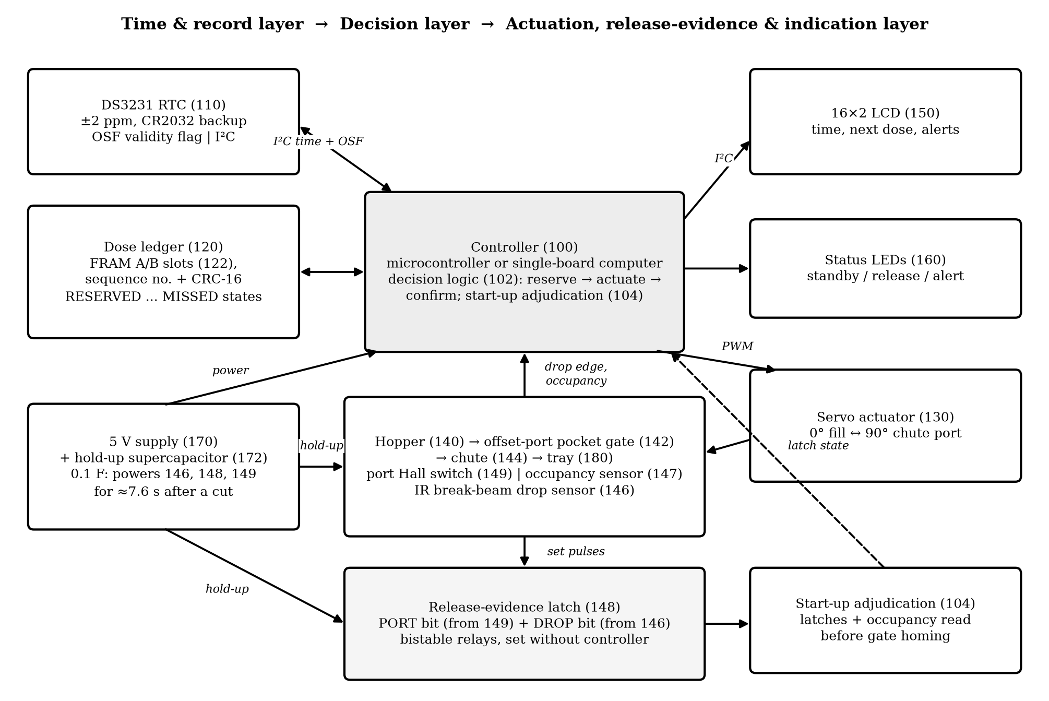
Figure 1: Layered Architecture with the Release-Evidence Path and Reference Numerals
[0009] Figure 1 divides the device into three layers. The time and record layer holds the RTC (110) and the ledger (120). The controller (100), running the decision logic (102) and the start-up adjudication (104), forms the decision layer. The servo (130), hopper (140), gate (142), chute (144), drop sensor (146), occupancy sensor (147), latch (148), Hall switch (149), LCD (150), LEDs (160) and tray (180) make up the actuation, evidence and indication layer. The supply (170) feeds all of them, and the hold-up capacitor (172) feeds only 146, 148 and 149.
7.2 Components and Ratings
Table 5: Components, Interfaces and Key Ratings
Ref. | Module | Implementation / interface | Function and key rating
100 | Controller | Single-board computer (prototype: Raspberry Pi) | 1 s decision loop, ledger I/O, PWM, latch reset
110 | RTC | DS3231, I²C 0x68, CR2032 backup | ±2 ppm at 0–40 °C, OSF validity flag
120/122 | Ledger | FRAM A/B slots (MB85RC256V, I²C) with sequence number and CRC-16; history file on removable card | Per-dose states; survives a torn write
130 | Actuator | SG90-class servo, 5 V, 50 Hz PWM | 0° fill and 90° port, 0.1 s per 60°
140/142 | Hopper and gate | Bulk hopper over a single-pocket plate with offset ports | One pocket load per cycle
144/146 | Chute and drop sensor | IR break-beam pair across the chute | Detects each falling tablet, edge ≈4 ms
147 | Occupancy sensor | TCRT5000 reflective, above the port position | Pocket loaded or empty at the port
148 | Evidence latch | Two two-coil bistable relays, 148a PORT, 148b DROP | State kept with no power; 15 ms set pulse
149 | Port Hall switch | DRV5023, magnet on the plate | Trips at 75° of travel
150/160 | Display and LEDs | 16×2 LCD with PCF8574, two LEDs via 330 Ω | Time, next dose, alerts
170/172 | Supply and hold-up | 5 V adapter; 0.1 F, 5.5 V supercapacitor, 22 Ω charge | Evidence path ≈7.6 s after a cut

[0010] Table 5 lists each module with its interface and the rating that matters for dosing and for evidence retention.
7.3 Electrical Interconnection and Hold-Up Budget
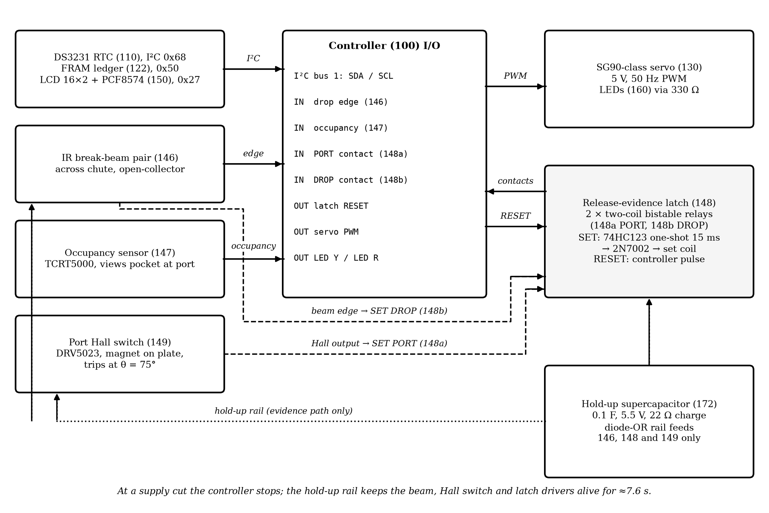
Figure 2: Interconnection of the Controller, Evidence Sensors, Latch Relays and Hold-Up Rail
[0011] As Figure 2 shows, the RTC and LCD share I²C bus 1 and the servo takes a PWM output. The beam receiver output feeds both a controller input and a 74HC123 one-shot that stretches the 4 ms beam break to a 15 ms pulse, which switches a 2N7002 transistor into the set coil of relay 148b. The Hall switch drives the set coil of relay 148a in the same way. Both relays' contacts are read as controller inputs, and the reset coils are pulsed by the controller. The supercapacitor charges through 22 Ω from the 5 V rail, a time constant of 2.2 s that completes well within the 25–27 s boot, and a diode-OR rail feeds the beam, Hall switch and relay drivers, but not the controller.
Table 6: Hold-Up Energy Budget of the Evidence Path
Quantity | Value | Basis
Evidence-path current I | 26 mA | IR emitter 20 mA, receiver 1 mA, Hall switch 3 mA, one-shots and drivers 2 mA
Relay set charge | 1.5 mC | 2 relays × 50 mA × 15 ms
Usable charge Q = C·ΔV | 0.200 C | C = 0.1 F, 5.0 V → 3.0 V
Hold-up time t = (Q − 1.5 mC)/I | 7.6 s | (0.200 − 0.0015)/0.026
Required hold-up | 0.115 s | Longest tablet flight 0.10 s + set pulse 0.015 s
Margin | 66 × | 7.6/0.115

[0012] Table 6 shows that the evidence path stays powered 66 times longer than the longest interval in which a tablet can still be in flight after a cut. The margin also covers capacitor ageing and the lower voltage limit of the relay coils.
7.4 Prototype as Built
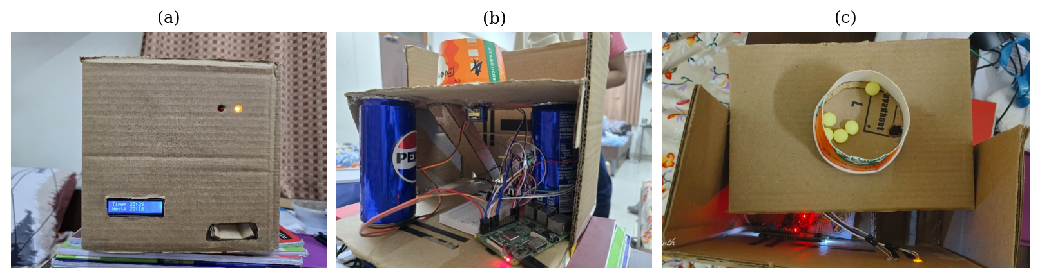
Figure 3: Prototype Mechanism as Built, (a) Front Panel with LCD and Status LEDs, (b) Internal Arrangement of Controller, Servo and Wiring, (c) Pill Hopper on the Gate Plate
[0013] The prototype in Figure 3 puts the controller, DS3231 RTC, servo gate, LCD and LEDs in a corrugated-board enclosure with a cardboard gate plate. It runs the earlier record-before-cycle logic with a single DISPENSED state. The evidence path of Sections 7.3 and 7.5, the occupancy sensor and a rigid gate plate remain to be fitted before the physical validation of Section 8.13. Section 8.9 reports what the prototype achieved as built.
7.5 Isolating Single-Pocket Gate with Evidence Sensors
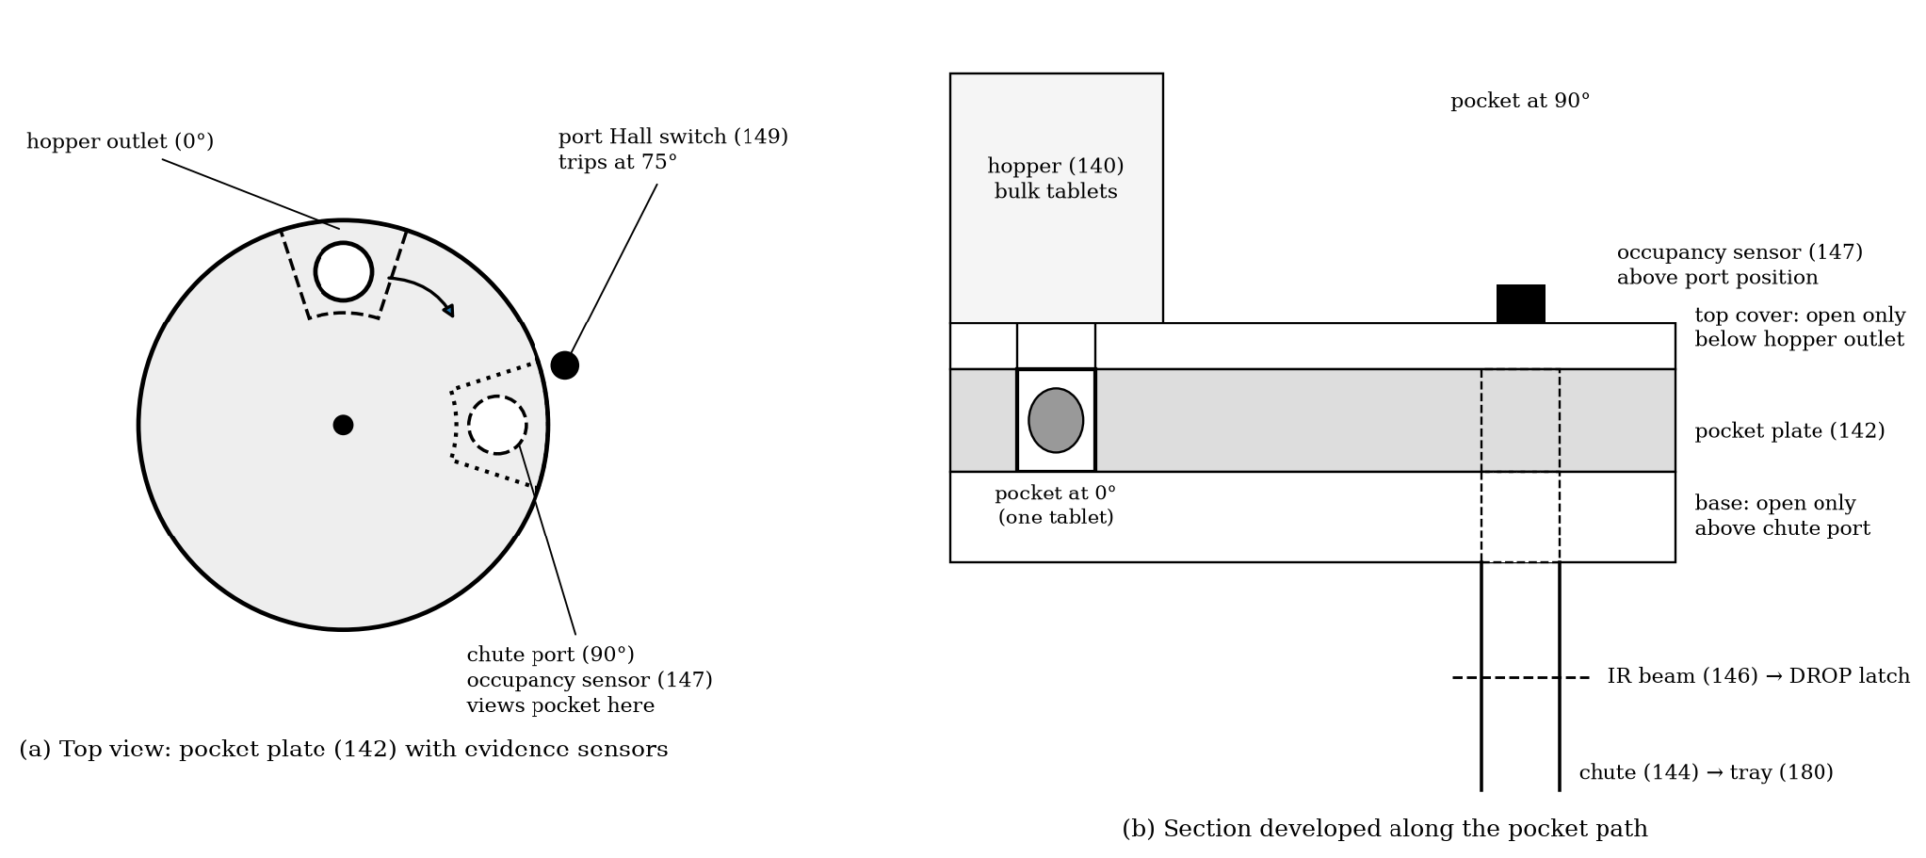
Figure 4: Single-Pocket Gate with Port Hall Switch and Occupancy Sensor, (a) Top View, (b) Section Along the Pocket Path
[0014] The pocket plate (142) in Figure 4 turns between two fixed layers. The top cover is open only beneath the hopper outlet at 0° and the base only above the chute port at 90°, so the pocket fills at 0° and empties at 90°, and no plate angle links hopper to chute. A magnet on the plate trips the Hall switch (149) at 75°, before the pocket overlaps the port enough for a tablet to leave, so the PORT bit is always set before any release is possible. A clear PORT bit therefore proves that the reserved tablet is still in the device. The occupancy sensor (147) above the port position views the pocket whenever it is at or near the port. A spring-return plate that closes to the fill position when unpowered was considered and not adopted: returning to the fill position refills an empty pocket from the hopper, so a loaded pocket at start-up would no longer show that the reserved tablet stayed in. Without a spring the plate stays where the cut left it, and the PORT bit records whether the port was reached.
[0015] One tablet seats in the pocket when d_p < D_a < 2 d_p and t_p ≤ h_a < 2 t_p, where d_p and t_p are the tablet diameter and thickness, D_a the pocket diameter and h_a the plate thickness. A round 8 mm × 4 mm tablet meets both with D_a = 9.5 mm and h_a = 5 mm. Meeting them is necessary but not sufficient, since tablet shape, coating friction and hopper fill level also affect seating (Section 8.9).
7.6 Time Layer and Clock Validity
[0016] DS3231 drift grows as Δt_drift = ε · t, with ε = 2 × 10⁻⁶ between 0 and 40 °C, which is 0.173 s per day or 5.18 s over 30 days. Two conditions block every release: a set oscillator-stop flag, which the DS3231 raises after its oscillator has stopped, for example when the main supply and the backup cell have both been lost, and a time reading more than 2 s behind the latest ledger timestamp. The caregiver utility clears both by setting the time.
7.7 Decision Logic
[0017] For a candidate dose d with scheduled time t_s(d) and ledger state S(d), evaluated at a valid time t, the dose is released when S(d) is empty and 0 ≤ t − t_s(d) ≤ W, and committed as MISSED when S(d) is empty and t − t_s(d) > W. Any dose with a stored state is not released by the poll loop. The only further release of a dose already in RESERVED is the completion cycle permitted by the start-up adjudication of Table 7, which requires retention proof.
Table 7: Start-Up Adjudication of a Dose Found in RESERVED
PORT (148a) | DROP (148b) | Occupancy (147) | Physical meaning | Committed outcome
any | set | any | Tablet crossed the chute | CONFIRMED
clear | clear | any | Pocket never reached the port; tablet retained | One completion cycle if within W, else MISSED
set | clear | loaded | Tablet still in the pocket at the port | One completion cycle if within W, else MISSED
set | clear | empty | Tablet left the pocket, passage not evidenced | UNCERTAIN, "Check dose" alert

[0018] Table 7 is the core of the start-up adjudication. Delivery evidence and retention evidence come from different sensors and resolve different interruption instants. Only the last row, in which the tablet has left the pocket but its passage was not seen, is referred to a person. That row arises only when the beam misses a tablet, since a tablet in flight at the cut is still seen through the hold-up rail.
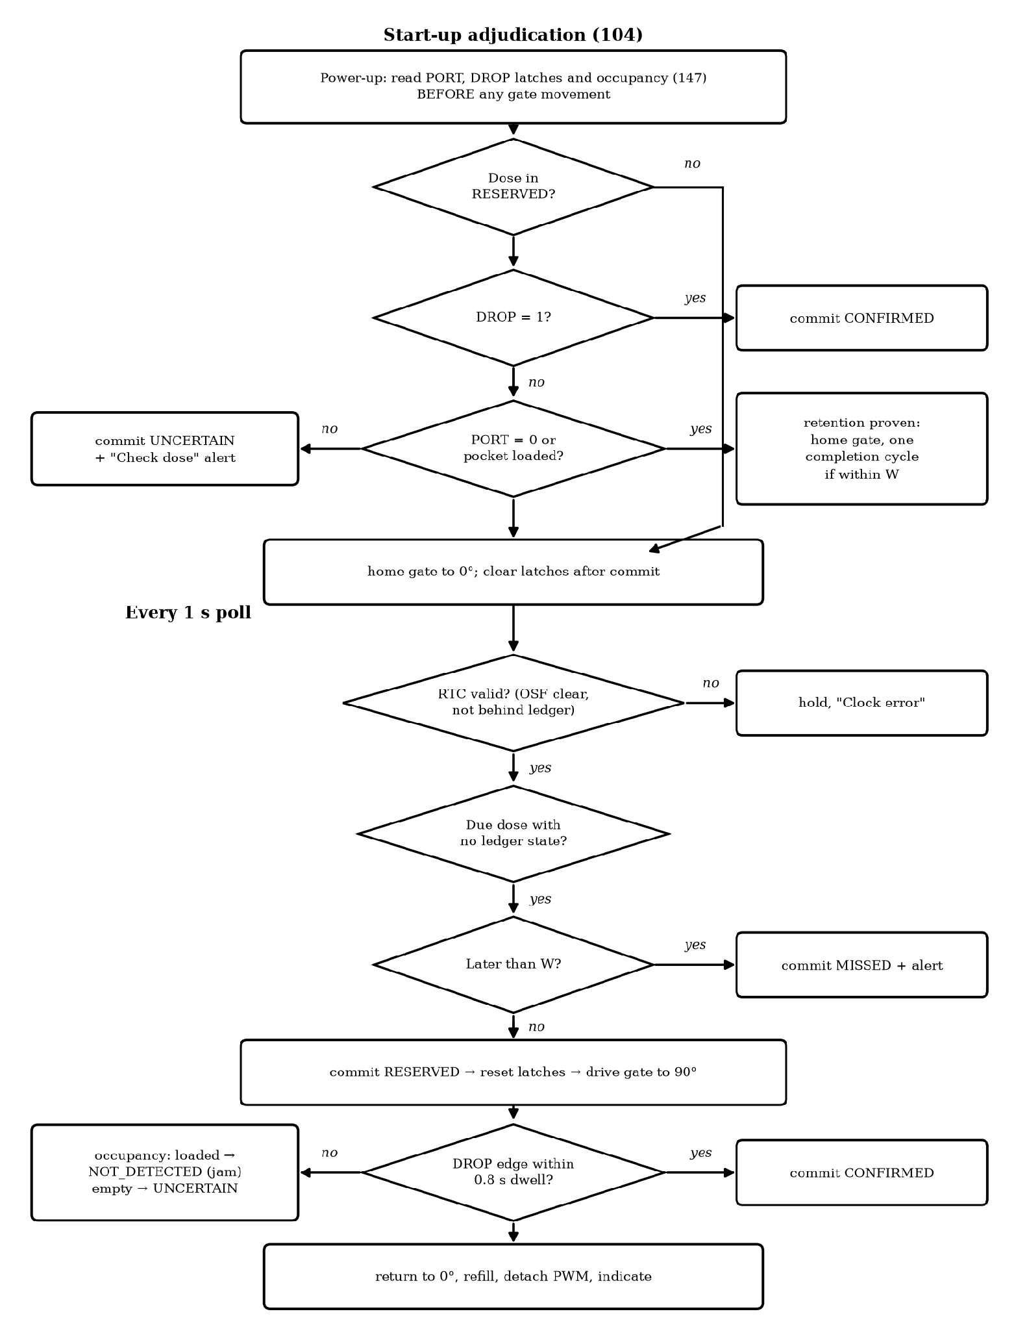
Figure 5: Control Flow of the Start-Up Adjudication and of Every 1 s Poll
[0019] Figure 5 draws this logic. The adjudication runs before any gate movement, because homing would carry a retained tablet back to the fill position and destroy the occupancy evidence.
7.8 Release Cycle Timing and Latch Behaviour
[0020] At 50 Hz the servo pulse width is p(θ) = 0.5 ms + (θ/180°) × 2.0 ms, so 0° needs 0.5 ms and 90° needs 1.5 ms, and travel takes 0.15 s. The Hall switch trips at 75°, 0.125 s after the command. A tablet falls the 50 mm chute in t_fall = √(2h/g) = 0.101 s and crosses the beam at v = √(2gh) = 0.99 m s⁻¹, so a 4 mm tablet breaks the beam for about 4 ms, the reason the edge is stretched to 15 ms by the one-shot before it drives a relay coil. The dwell T_dwell = 0.8 s is counted from the command, and T_settle = 0.5 s covers the 0.15 s return and refilling, so one cycle lasts 1.3 s. The controller resets the latches after the outcome is committed and the gate is home.
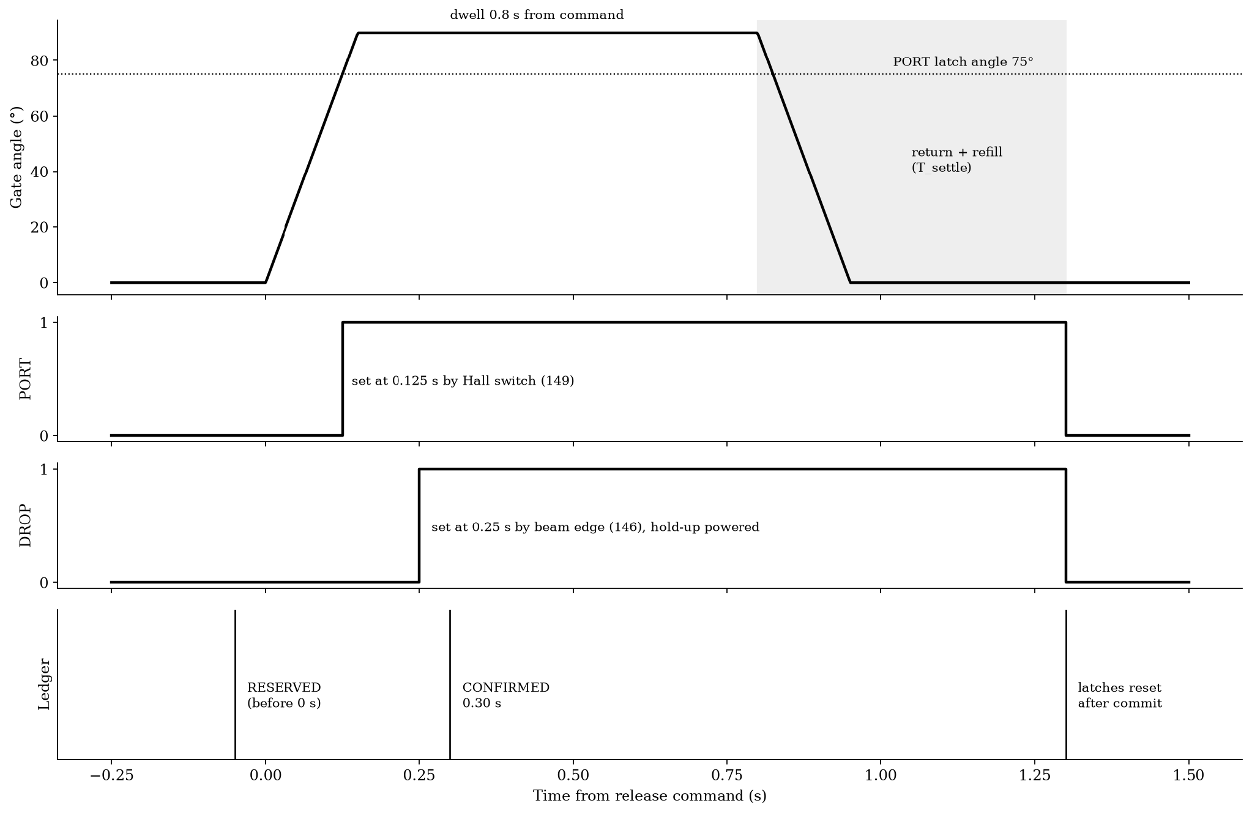
Figure 6: Timing of One Release Cycle with PORT and DROP Latches and Ledger Commits
[0021] Figure 6 marks where each latch is set and each commit falls. A cut before 0.125 s leaves PORT clear; a cut between 0.125 s and 0.15 s leaves PORT set with the tablet still in the pocket; a cut after 0.15 s leaves the tablet falling, and the hold-up rail lets it set DROP at 0.25 s. Each case maps to a row of Table 7.
7.9 Indication and Equivalent Implementations
[0022] Between events the LCD reads Time: HH:MM and Next: HH:MM. Alerts appear as "Missed dose", "Not dispensed" (NOT_DETECTED), "Check dose" (UNCERTAIN) or "Clock error", and the red LED blinks until acknowledged. A microcontroller such as an ESP32 or STM32 can replace the single-board computer, with the ledger in FRAM or the EEPROM on the DS3231 module. The bistable relays can be replaced by a FRAM bit written by an always-on logic block, or by the event-timestamp input of an RTC that has one. A reflective sensor can replace the beam, an optical interrupter the Hall switch, and a stepper motor the servo. Several hoppers, each with its own gate, sensors and latch pair, can share one ledger.
7.10 Boot Time, Repeated Interruptions and Ledger Integrity
[0023] Boot time. The single-board controller of the prototype needs 25–27 s to boot. Boot time does not affect the correctness of the adjudication, because the evidence is written by the relays at the moment of the event and is read whenever the controller next starts. The relay contacts hold their state with no power, and the controller clears them only after an outcome for that dose has been committed. A second or third cut during boot, as in Campaign D, therefore cannot erase or alter the evidence: each start-up reads the same contacts until one start-up completes the commit. Boot time affects only when the adjudication happens. A completion cycle must still fall within W = 30 min, which a 27 s boot barely touches, and the hold-up capacitor recharges (5τ = 11 s) before the first release after boot. Where faster recovery is wanted, the microcontroller embodiment of Section 7.9, which typically boots in under a second, runs the same adjudication; this shortens the delay before the outcome without changing the outcome.
[0024] Ledger integrity. The dose ledger (120) is held twice. The working copy is a pair of record slots in an I²C FRAM (122), a 256 Kbit MB85RC256V on the same bus as the RTC. Each commit writes the per-dose record, consisting of the dose key, state, commit time, a sequence number that only increases and a CRC-16, to the older of the two slots, so the other slot always holds the previous valid record. At start-up the controller takes the slot with the higher sequence number whose CRC is valid; a write interrupted by a supply cut leaves a slot with a bad CRC, which is ignored. The removable card keeps an append-only history for the caregiver and is never the source of an adjudication. An FRAM record write completes in well under a millisecond, inside the 0.05 s commit step of Section 7.8, and FRAM endurance of the order of 10¹² write cycles far exceeds the life of a device that commits a few records a day.
[0025] Alternative evidence sources. The release sensor need not be a chute beam. A load cell or optical sensor under the delivery tray that responds to a tablet arriving serves the same role, provided its output sets the DROP relay from the hold-up rail. The dose store may likewise be battery-backed SRAM, such as the user memory of an RTC, instead of FRAM. A check that the tray is empty before a completion cycle is a further form of release evidence and fits the same adjudication. Keeping the controller itself alive on a hold-up store long enough to observe the drop and finish the commit, as US4366481A does for transaction data, is a weaker alternative: a single-board controller draws several hundred milliamperes against the 26 mA of the evidence path, so the capacitor would have to be roughly twenty times larger for the same hold-up time, and a controller that crashes or resets during the cut still loses the observation, whereas a relay set by the mechanism does not.
[0026] Double release and several hoppers. When the beam counts two or more edges in one dwell, the controller stores a double-release alert and, where the tray door carries a solenoid lock, holds the door closed until a caregiver clears the alert, so that a second tablet cannot be taken unnoticed. Several hoppers, each with its own gate, Hall switch, release sensor and latch pair, can share one dose ledger; records and latch reads are then keyed by hopper and dose, and the start-up adjudication of Table 7 runs for each hopper in turn.
8. Experimental Validation Results
8.1 Experimental / Validation Setup
Validation ran at three levels, and the scope of each is stated so that the evidence is read for what it is.
(i) Prototype trials. The prototype mechanism (Figure 3) ran the earlier record-before-cycle logic with no drop sensor. In 200 normal dispensing attempts with one tablet type, the number of tablets reaching the tray was noted each time, and 50 supply-cut trials ended with a check of gate commands and ledger entries after restart.
(ii) Software-in-the-loop (SIL) and behavioural model. The earlier SIL validation ran the controller of the two-phase arrangement and three conventional controllers against a DS3231 model, a gate model and a drop-sensor model, with a supply interruption discarding everything except the ledger. For the evidence arrangement, a discrete-event behavioural model of one release cycle was built from the timing of Section 7.8 and the hold-up budget of Table 6. The model was first checked against the earlier SIL: for the two-phase arrangement it reproduces the earlier Campaign C result exactly in every cut-instant bin (159 CONFIRMED, 25 UNCERTAIN with no tablet, 16 UNCERTAIN with a tablet). It was then applied to four variants on the same 200 cut instants:
- Two-phase ledger (earlier design): reservation and drop-edge confirmation, no latch, no occupancy sensor.
- Drop latch only (M1): adds the DROP relay on the hold-up rail.
- Retention evidence only (M2): adds the PORT relay and the occupancy sensor, without the DROP relay.
- Full evidence arrangement: all of the above.
The model assumes a pocket jam probability of 0.02 per cycle, a little above the 1.5 % non-release measured on the prototype, and a beam-miss rate of 0 %, 1 % or 5 %, since the physical false-negative rate is still to be measured (test P4). The occupancy sensor and relays are modelled as error-free.
(iii) Calculations. Drift, timing, beam-break duration and hold-up time were calculated from component data (Sections 7.3, 7.6 and 7.8).
8.2 Configuration / Operating Parameter Values
Table 8: Configuration Parameters
Parameter | Value | Basis
Schedule | 08:00, 14:00 and 21:00 | Three-times-daily regimen
Catch-up window W | 30 min | Recovery without approaching the next dose
Polling period and clock tolerance | 1 s and 2 s | Controller loop and guard
Gate angles and PWM pulse | 0° / 90° and 0.5 / 1.5 ms | Section 7.8
PORT latch angle | 75° (0.125 s) | Before release is possible
T_dwell / T_settle | 0.8 s / 0.5 s | Release cycle
Servo travel and tablet fall | 0.15 s and 0.10 s | SG90 speed, 50 mm chute
One-shot pulse and hold-up time | 15 ms and 7.6 s | Table 6
Jam probability and beam-miss rate | 2 % and 0 / 1 / 5 % | Section 8.1
RTC accuracy | ±2 ppm at 0–40 °C | DS3231 data sheet

Table 8 holds for every campaign unless a campaign states otherwise.
8.3 Validation Campaigns and Outcome Categories
Table 9: Validation Campaigns
ID | Campaign | Size | Condition
A1 | Continuous operation | 30 days, 90 doses | No fault
A2 | Scheduling latency | 300 boots | Random poll phase
B | Interruptions around dose times | 500 trials, 202 affected doses | Cut from 120 min before to 40 min after a dose, 10 s to 8 h long
C | Cut inside the release cycle | 200 trials | Cut instant uniform over 0–1.3 s, supply off 5–600 s
D | Restart burst | 100 trials | Three 1–4 s cuts starting 0.5–5 s after the 14:00 dose
J | Pocket jams and beam misses | 1 800 doses | 2 % jams; beam-miss 0, 1, 5 %
E | Edge cases | 6 cases | Window limits, midnight, restart, clock faults

Table 9 summarises the campaigns. Each dose is classed by the number of tablets released and by its ledger state. Duplicates, false records and silent misses count as hazardous. A human check is counted whenever an alert asks the user to inspect the tray (UNCERTAIN or NOT_DETECTED).
8.4 Scheduling Latency
In Campaign A1 all controllers cycled the gate once for each of the 90 doses; without faults they cannot be told apart.
Table 10: Scheduling Latency Over 300 Boots
Statistic | Value (s) | Remark
Mean / median | 0.470 / 0.455 | T_p/2 = 0.5
Standard deviation | 0.278 | T_p/√12 = 0.289
95th percentile and maximum | 0.951 and 0.998 | Below T_p = 1 s
Pocket at chute port (maximum + 0.15) | 1.148 | Section 7.8

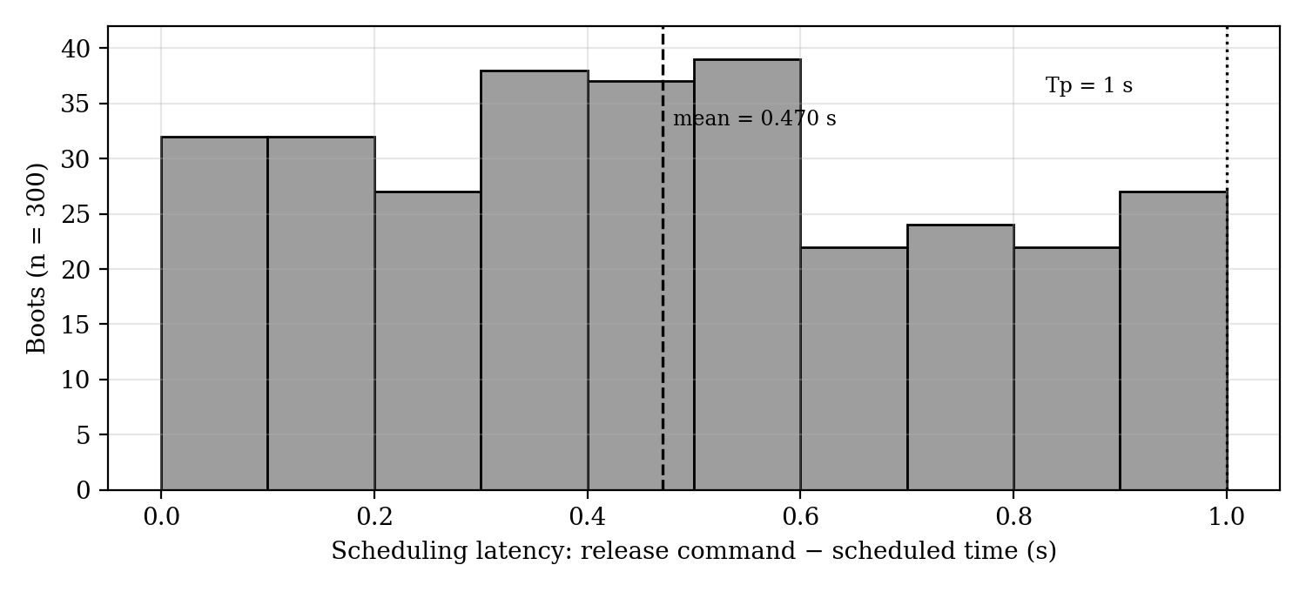
Figure 7: Distribution of Scheduling Latency Over 300 Boots
Table 10 and Figure 7 show latency spread evenly below the polling period, with mean and spread matching a random poll phase. The decision logic adds no measurable delay before the servo command. The evidence path is not expected to add delay, since the latch reset pulse is issued in the same step as the RESERVED commit; this is to be confirmed in test P1.
8.5 Interruptions Around the Scheduled Time (Campaign B)
Table 11: Outcome of 202 Affected Doses
Outcome | Ledger-based controllers | Time-match
Controller available within W, tablet once | 113 | 75
Controller available within W, silent miss | 0 | 38
Window elapsed during outage, MISSED with alert | 89 | 0
Window elapsed during outage, silent miss | 0 | 89

The ledger-based controllers of the earlier SIL gave identical results, and none of the 202 affected doses had a cut inside the release cycle, where alone the full evidence arrangement behaves differently; its outcome is therefore the same. Releases rose from 75 to 113 and silent misses fell from 127 to zero relative to time-match, a gain from the persistent ledger and window W. Cuts inside a 1.3 s cycle are rare here, which is why Campaign C tests them directly.
8.6 Interruption Inside the Release Cycle (Campaign C)
Table 12: Campaign C Outcomes by Cut Instant (200 Trials, Beam-Miss Rate 0 %)
Cut instant | n | Full evidence arrangement | Two-phase ledger | Record-after | Record-before | Time-match
0–0.15 s | 25 | 25 one tablet, CONFIRMED after completion cycle | 25 no tablet, UNCERTAIN | 25 one tablet | 25 false record | 24 silent miss, 1 tablet
0.15–0.30 s | 16 | 16 one tablet, CONFIRMED from DROP latch | 16 one tablet, UNCERTAIN | 16 duplicate | 16 one tablet | 15 one tablet, 1 duplicate
0.30–0.80 s | 83 | 83 one tablet, CONFIRMED | 83 one tablet, CONFIRMED | 83 duplicate | 83 one tablet | 77 one tablet, 6 duplicate
0.80–1.30 s | 76 | 76 one tablet, CONFIRMED | 76 one tablet, CONFIRMED | 76 duplicate | 76 one tablet | 69 one tablet, 7 duplicate
Hazardous / human checks | 200 | 0 / 0 | 0 / 41 | 175 / 0 | 25 / 0 | 38 / 0

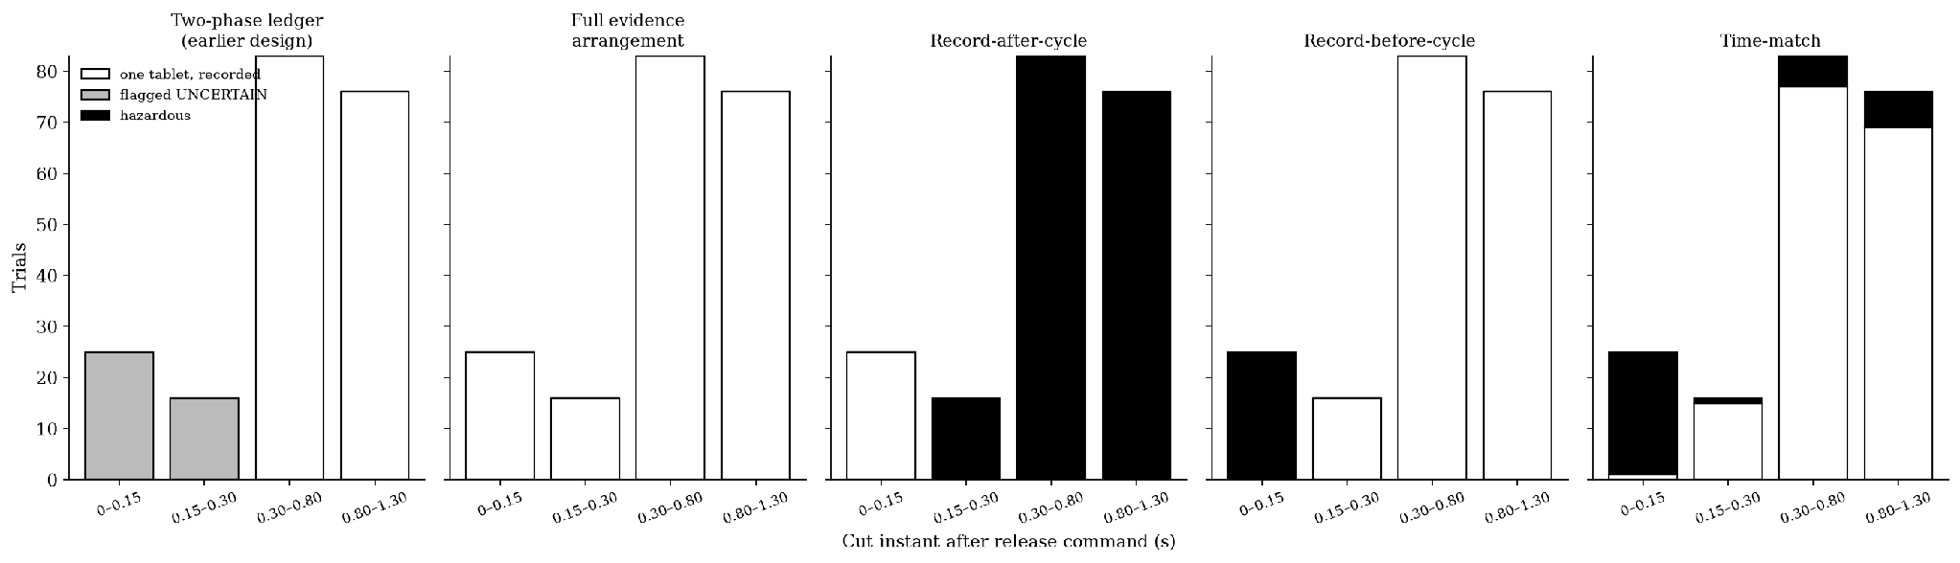
Figure 8: Campaign C Outcomes by Cut Instant for the Five Controllers
Table 12 and Figure 8 break Campaign C down by cut instant. Writing the record after the cycle duplicates the tablet in 175 of 200 cuts, and writing it before the cycle without confirmation gives 25 false records. The two-phase ledger was never hazardous but left 41 cuts unresolved: in 25 the tablet was still in the pocket and in 16 it was already in the tray. The full evidence arrangement resolved all 41. In the first bin, a clear PORT bit, or a loaded pocket for the few cuts after 0.125 s, proved retention and one completion cycle delivered the tablet. In the second, the tablet in flight crossed the still-powered beam and set DROP. Every trial ended with one tablet and a CONFIRMED record, and no person was asked to check the tray.
8.7 Contribution of Each Evidence Path (Ablation)
Table 13: Human Checks and False Records by Variant and Beam-Miss Rate
Variant | Checks, C (0 % / 1 % / 5 %) | False records, C + J (0 % / 1 % / 5 %) | Duplicates
Two-phase ledger | 41 / 44 / 52 | 0 / 17 / 98 | 0
+ drop latch only (M1) | 25 / 28 / 37 | 0 / 17 / 98 | 0
+ retention evidence only (M2) | 16 / 18 / 28 | 0 / 0 / 0 | 0
Full evidence arrangement | 0 / 3 / 13 | 0 / 0 / 0 | 0

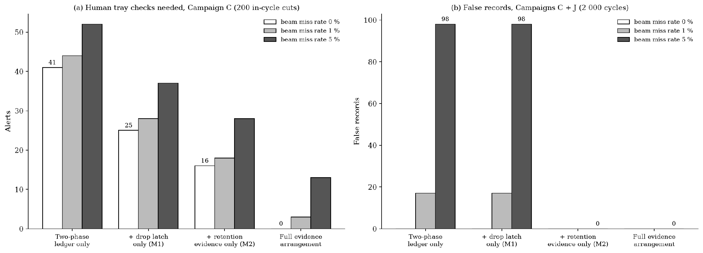
Figure 9: Human Checks and False Records for Each Evidence Path Alone and in Combination
Table 13 and Figure 9 separate the contribution of each part. At a perfect beam, the drop latch alone resolves the 16 cuts with a tablet in flight and the retention evidence alone resolves the 25 with the tablet still in the pocket. Each covers a different part of the release timeline, so neither alone removes more than 25 of the 41 checks, and only the combination, whose coverage is complete because of the trip-angle and hold-up dimensioning of Sections 7.5 and 7.8, removes all of them. With a 1 % and 5 % beam-miss rate, the variants without occupancy evidence record 17 and 98 delivered doses as not dispensed, a false record that invites a second tablet. Occupancy at the port converts each of these into a truthful UNCERTAIN alert. The full arrangement is therefore the only variant with zero duplicates, zero false records and the fewest checks at every tested miss rate. Its remaining 3 and 13 checks in Campaign C are exactly the beam misses on tablets that did leave, the last row of Table 7.
8.8 Restart Bursts, Pocket Jams and Hazard Summary (Campaigns D and J)
Table 14: Restart Bursts (D) and Pocket Jams (J) at Beam-Miss Rate 0 %
Campaign and class | Full evidence | Two-phase | Record-after | Record-before | Time-match
D, one tablet recorded | 100 | 96 | 77 | 99 | 4
D, flagged for a person | 0 | 4 | 0 | 0 | 0
D, duplicate / false record | 0 / 0 | 0 / 0 | 23 / 0 | 0 / 1 | 96 / 0
J, delivered (1 800 minus 37 jams) | 1 763 | 1 763 | 1 763 | 1 763 | 1 763
J, 37 jams recorded truthfully with alert | 37 | 37 | 0 | 0 | 0
J, 37 jams as false record / silent miss | 0 / 0 | 0 / 0 | 37 / 0 | 37 / 0 | 0 / 37

Campaign D was not re-run in the behavioural model. In the earlier SIL the first cut interrupted the release cycle in four trials, three ending UNCERTAIN with the tablet in the tray and one without; the other 96 cuts fell outside the cycle. Applying Table 7 to those four trials, the first three resolve from the DROP latch and the fourth from retention proof, which gives the 100 single tablets with no flag shown for the full arrangement. In Campaign J the occupancy sensor recorded every jam as NOT_DETECTED with the tablet still in the pocket.
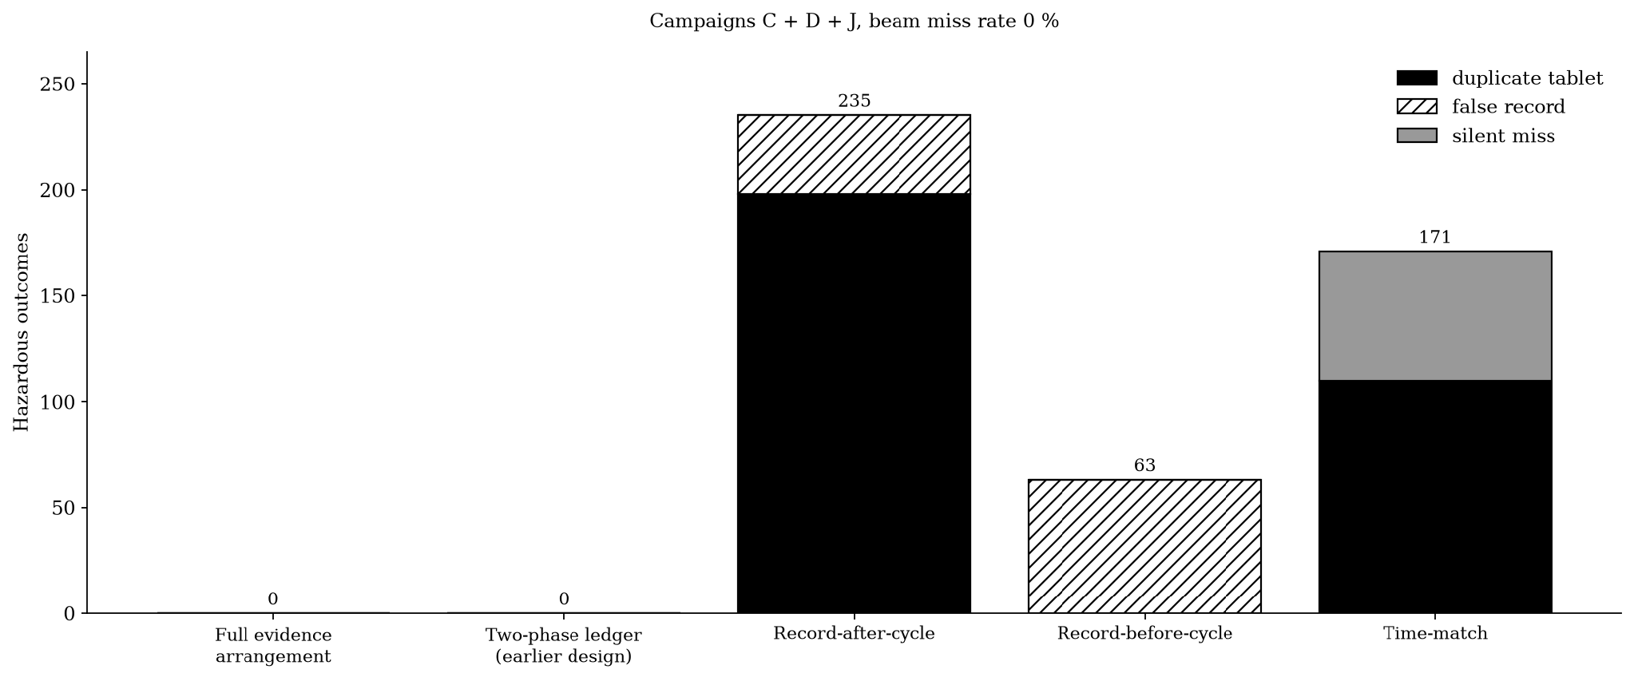
Figure 10: Hazardous Outcomes Across Campaigns C, D and J
Figure 10 totals the hazards of Campaigns C, D and J. The full evidence arrangement and the two-phase ledger had none; record-after-cycle had 235 (198 duplicates, 37 false records), record-before-cycle 63 false records and time-match 171 (110 duplicates, 61 silent misses). The difference between the two hazard-free arrangements lies in Table 13: 45 human checks against none at a perfect beam, and false records against none once the beam misses.
8.9 Edge Cases, Clock Integrity and Physical Prototype Results
Table 15: Edge Cases (Tablets for the Dose / Ledger State / Alert)
Case | Full evidence | Ledger baselines | Time-match
E1 outage 07:55–08:20 | 1 / CONFIRMED / none | 1 / DISPENSED / none | 0 / none / none
E2 outage 07:50–08:40 | 0 / MISSED / alert | 0 / MISSED / alert | 0 / none / none
E3 dose 23:50, outage 23:45–00:05 | 1 / CONFIRMED / none | 1 / DISPENSED / none | 0 / none / none
E4 restart 20 s after 08:00 release | 1 / CONFIRMED / none | 1 / DISPENSED / none | 2 / none / none
E5 RTC set back 1 h at 08:10 | 1 / CONFIRMED / clock alert | 1 / DISPENSED / none | 1 / none / none
E6 backup cell lost, RTC reads 00:00 at 07:00 with OSF set | 0 tablets / clock alert | 1 tablet at 15:00 | 1 tablet at 15:00

Table 15 covers the edge cases, taken from the earlier SIL. None involves a cut inside the release cycle, so the full arrangement behaves as the two-phase ledger there. In E6, controllers that trust any RTC reading released a tablet seven hours late with no warning; the clock guard released nothing and reported a clock error.
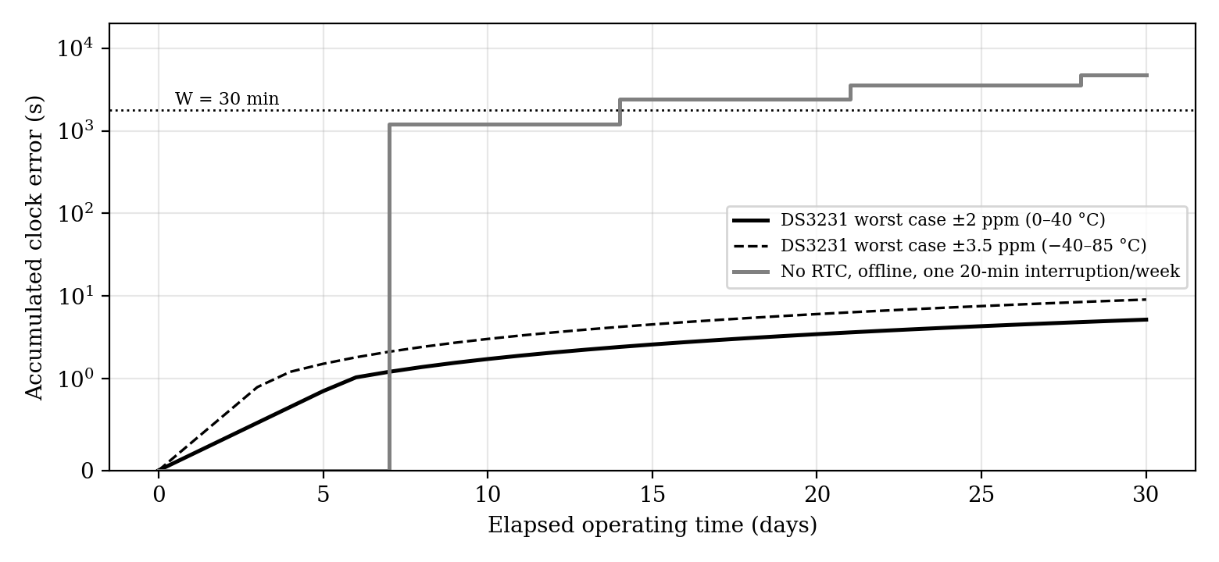
Figure 11: Accumulated Clock Error With and Without the DS3231 RTC
Figure 11 compares time sources. At ±2 ppm the DS3231 accumulates 0.173 s per day and 5.18 s over 30 days, whereas a controller with no battery-backed clock and one 20 min interruption per week drifts past W inside the first week.
Table 16: Prototype Dispensing Results, One Tablet Type (n = 200)
Outcome per attempt | Count | Share | 95 % interval (Wilson)
Exactly one tablet released | 196 | 98.0 % | 95.0–99.2 %
No tablet released | 3 | 1.5 % | 0.5–4.3 %
Two tablets released | 1 | 0.5 % | 0.1–2.8 %

The three non-releases match the jam case of Campaign J; with the occupancy sensor they would be stored as NOT_DETECTED with the tablet in the pocket, whereas the prototype logged them as dispensed. The double release produced a duplicate with no repeated command, either through double seating or a held-back tablet falling with the next, and no record ordering can stop it. Counting beam edges during the dwell, a dependent feature in Section 10, flags such an event. Over 50 supply-cut trials the prototype never repeated a gate command, as writing the record before actuation intends, but cuts before the gate moved left DISPENSED with no tablet in the tray, the same false record the SIL showed for record-before-cycle.
8.10 Overall Performance Metrics
Table 17: Overall Performance Metrics
Metric | Full evidence | Best comparison | Source
Hazardous outcomes, C + D + J (0 % miss) | 0 | 0 (two-phase) | Fig. 10
Human checks, C + D (0 % miss) | 0 | 45 (two-phase) | Tables 12, 14
False records, C + J (1 % / 5 % miss) | 0 / 0 | 0 / 0 (retention only) | Table 13
Human checks, C (1 % / 5 % miss) | 3 / 13 | 18 / 28 (retention only) | Table 13
Maximum gate cycles per dose | 2 (completion on proof) | 1 (two-phase) | Table 7
Latency mean / maximum | 0.470 / 0.998 s | Same | Table 10
Evidence hold-up time | 7.6 s (66 × required) | n/a | Table 6
Prototype single-tablet release (measured) | 196/200 (98.0 %) | n/a | Table 16
Prototype repeat commands after power cut (measured) | 0 in 50 trials | n/a | Section 8.9

Table 17 shows the full arrangement as the only one that is hazard-free and needs no human check at a perfect beam, and the only one with no false records and the fewest checks when the beam misses. The second gate cycle permitted per dose is used only when retention is proven, so it cannot release a second tablet.
8.11 Integrated Technical-Effect Summary
Table 18: Technical Effects, Mechanism and Evidence
Effect | How achieved | Evidence
No duplicate tablet | Reservation before actuation; completion only on retention proof | 0 against 198 (record-after)
No human check for resolvable cuts | Latched PORT and DROP evidence read at start-up | 0 against 41 (two-phase), C
No false record under beam misses | Occupancy at the port at dwell end and start-up | 0 against 17 / 98 (1 % / 5 %)
Evidence retained after the controller stops | Hold-up rail on beam, Hall switch and relay drivers only | 7.6 s, 66 × required
No release on invalid clock | OSF and monotonic guard | E6: 0 tablets against 1 at +7 h

Table 18 ties each effect to the mechanism behind it and to the campaign that measured it.
8.12 Key Validation Insights
- Without faults all controllers behave identically; everything the invention adds shows up only under faults.
- A persistent ledger alone cures silent misses (Campaign B); written after the cycle it duplicated the tablet in 87.5 % of in-cycle cuts.
- A two-phase ledger is hazard-free but must ask a person after 20.5 % of in-cycle cuts, most of which are physically resolvable.
- The drop latch and the retention evidence resolve disjoint classes of cut; only together do they remove all 41 checks.
- Occupancy evidence is what keeps a beam miss from becoming a false record, 17 and 98 of them at 1 % and 5 % miss rates without it.
- On hardware, the record-before-cycle prototype never repeated a command in 50 cuts and produced false DISPENSED records for cuts before the gate moved, consistent with the SIL for that arrangement.
8.13 Limitations and Physical Validation Plan
The results for the evidence arrangement come from a behavioural model that reproduces the earlier SIL exactly for the two-phase ledger, not from hardware. The prototype mechanism ran earlier logic with no drop sensor, latch, occupancy sensor or rigid plate. The model treats the relays and occupancy sensor as error-free and the beam-miss rate as a parameter. The single double release in 200 prototype attempts shows that a mechanical duplicate remains possible and must be flagged by edge counting. The FRAM A/B ledger of Section 7.10 has been specified but not yet tested against induced corruption (test P6). The open items are the physical tests of Table 19, and completing P1 and P2 on the full device is the condition for TRL 4.
Table 19: Physical Validation Plan for the Complete Device
Test | Method | Measured outputs | Minimum useful result
P1 Supply cut at each cycle step | Relay-switched 5 V supply at programmed delays 0–1.3 s, ≥30 per step; full arrangement vs two-phase vs record-before vs record-after | Tray tablets, ledger state, latch states, alerts | 0 duplicates; checks ≤5 in 200 against about 41
P2 Evidence-path ablation | Latch only vs retention only vs both, same cut schedule | Resolved and unresolved cuts | Combination resolves more than either alone
P3 Stall-angle test | Cuts at 10 plate angles, 20 each | PORT state vs tablet position | PORT clear in every stall with the tablet retained
P4 Sensor error rates | ≥1 000 drops with dust, ambient light and doubles | Beam miss, occupancy error, double detection | Measured rates replacing the model parameters
P5 Tablet forms and fill level | Three shapes, three sizes, three fill levels, ≥100 cycles each | Single-tablet rate, jams, double seating | Plate sizing rule confirmed
P6 Endurance and ledger integrity | ≥3 000 cycles with random cuts, including cuts timed during FRAM writes | Relay and servo wear, ledger integrity, hazards | No hazardous outcome

The expected outcomes of the physical tests have been calculated in advance from the timing of Section 7.8, the hold-up budget of Table 6 and the behavioural model of Section 8.1, and serve as the acceptance criteria against which P1 and P2 will be judged (Table 20). A first hardware run may show a few UNCERTAIN cases caused by sensor alignment or missed beam edges; for that reason the minimum useful P1 result is five or fewer checks in 200 trials rather than zero.
Table 20: Calculated Expected Outcomes and Acceptance Criteria for Tests P1 and P2
Item | Calculated expectation | Acceptance criterion
Hold-up after 5 V is removed | 7.6 s of evidence-path operation (Table 6); range about 7–8 s allowing for capacitor tolerance | Beam, Hall switch and relay drivers active for at least 0.115 s
PORT latch timing | Set about 0.125 s after the gate command, Hall switch at about 75° | Set before the pocket first opens to the port
DROP latch | Set as the tablet crosses the beam after a fall of about 0.10 s, with the beam pulse stretched to 15 ms; remains set with no power | Relay state unchanged after power removal
P1, cut before about 0.125 s | PORT = 0, DROP = 0, tablet retained; one completion cycle at restart | One tablet, CONFIRMED
P1, cut at about 0.125–0.15 s | PORT = 1, DROP = 0, TCRT5000 reports the tablet present; one completion cycle at restart | One tablet, CONFIRMED
P1, cut after about 0.15 s | PORT = 1, DROP = 1 once the falling tablet crosses the beam | CONFIRMED at restart, no second release
P1 overall, about 200 trials | 0 duplicates and 0 false records; 0 checks under ideal sensing | 0 duplicates, 0 false records, 5 or fewer checks
P2, DROP latch only | Resolves the in-flight cases, about 16 of the 41 previously unresolved; about 25 remain | Resolved set matches the in-flight cut window
P2, retention evidence only (Hall + TCRT5000) | Resolves the retained-tablet cases, about 25 of 41; about 16 remain | Resolved set matches the retained-tablet cut window
P2, both evidence paths | Fewest unresolved cases, ideally 0 at a perfect beam | Fewer unresolved cases than either path alone

9. Discussion
A dispenser that loses power in the middle of a release faces one question at restart: did the tablet leave? The earlier two-phase arrangement answered it safely but not usefully. It never repeated a reserved dose and never claimed a release it had not seen, but because the controller was the only witness and the controller had stopped, every cut inside the cycle ended with a request to check the tray. In the validation that was 41 of 200 cuts, and in 25 of them the tablet had never left the pocket.
The present invention makes the mechanism its own witness. The Hall switch records that the pocket reached the port and the beam records that the tablet crossed the chute, each by setting a bistable relay from a small hold-up rail, without the controller. Because the gate never connects hopper and chute, a clear PORT bit is proof that the tablet is still inside, and the occupancy sensor adds the same proof for a pocket stopped at the port. The start-up logic reads this evidence before anything moves and settles each residual reservation from it. Delivery evidence gives CONFIRMED. Retention proof gives exactly one completion cycle, which cannot release a second tablet because the first is proven to be in the pocket. Only a tablet that left without being seen is referred to a person.
This differs from both families in the prior art. The retry family (CN105109722B, US6772906B2, US11213457B2, US8452446B1) repeats without proof of non-delivery and so risks a duplicate. The lockout family (US6732884B2) withholds even when the dose provably remained. Stage flags in programmable controllers (US4672573A) and saved machine states (US4948138A) record the controller's intent, not what the mechanism did. The evidence in the present invention is written by the mechanism, survives the controller, and is read before the controller acts, and that is what allows it to repeat safely where the art either repeats unsafely or not at all.
The ablation in Section 8.7 tests whether the parts earn their place. The drop latch alone resolves the cuts with the tablet in flight, 16 of 41. The retention evidence alone resolves the cuts with the tablet still in the pocket, 25 of 41, and it alone stops beam misses turning into false records. Neither alone reaches zero checks, and the drop latch alone leaves 17 and 98 false records at 1 % and 5 % miss rates. The combination removes all 41 checks and all false records at every tested miss rate, while the isolating gate is what makes a clear PORT bit a proof in the first place.
The limits are stated in Section 8.13. The arrangement's results come from a behavioural model that matches the earlier SIL exactly where the two overlap, not yet from hardware; the relays and occupancy sensor are modelled as error-free; and a mechanical double release, seen once in 200 prototype attempts, can only be flagged, not prevented, by record logic. The physical tests P1 to P6 define how those limits will be closed.
10. What Aspect(s) of the Invention Need(s) Protection?
System-level protection statement (apparatus). A tablet dispenser comprising a bulk hopper; a single-dose gate movable by an actuator between a fill position and an outlet position, the gate providing no path from the hopper to the outlet other than by carrying one pocket load to the outlet position; a release sensor responsive to a tablet passing from the outlet or arriving at a delivery tray; a position sensor arranged to respond as the gate approaches the outlet position and before the pocket first opens to the outlet; a non-volatile release-evidence latch settable by the release sensor and by the position sensor independently of any controller; a hold-up energy store supplying the release sensor, the position sensor and the latch after loss of the main supply; a non-volatile or battery-backed dose store; and a controller configured to (i) persist a dose-specific reservation before energising the actuator, (ii) commit a confirmed state on a release-sensor signal, (iii) clear the latch only after committing an outcome, and (iv) at start-up, before moving the gate, resolve each residual reservation from the latch state into a confirmed state when release is evidenced, into a single completion cycle when the position evidence or a pocket-occupancy signal shows that the tablet has not left, and otherwise into an alerted uncertain state.
Method statement. A method of releasing a scheduled dose comprising persisting a dose-specific reservation, energising a single-dose gate, latching position and release evidence in a store powered independently of the controller, and, after any interruption, determining from the latched evidence before any gate movement whether the dose is confirmed, may be completed exactly once, or must be referred to a person.
Protection is further sought for the following dependent aspects:
1. Bistable relay latch. The release-evidence latch comprises two-coil bistable relays whose set coils are driven from the release and position sensors through a pulse stretcher on the hold-up rail.
2. Alternative latch forms. The latch is a FRAM bit written by an always-on logic block, or the event-timestamp input of a real-time clock.
3. Pocket-occupancy discrimination. An occupancy sensor at the outlet position distinguishes a jammed tablet (not-detected state) from an unseen release (uncertain state) at the end of each dwell and at start-up.
4. Offset, face-covered ports. The hopper outlet and chute port are angularly offset and covered on opposite faces of the pocket plate.
5. Hold-up sizing. The hold-up store keeps the evidence path powered for at least the longest tablet flight plus the latch set pulse after loss of the main supply, without powering the controller.
6. Double-release detection. Beam edges are counted during the dwell and two or more edges produce a double-release alert.
7. Clock-validity interlock. Actuation is inhibited while the RTC oscillator-stop flag is set or the RTC time is behind the latest stored timestamp.
8. Catch-up window. A completion cycle or a first release is permitted only within a window W of the scheduled time, and otherwise a missed state is stored with an alert.
9. Torn-write-safe ledger. Dose records are written alternately to two non-volatile slots, each carrying a sequence number and a checksum, and the start-up adjudication reads only the newest slot whose checksum is valid.
10. Tray lock on double release. A double-release alert holds a solenoid-locked tray door closed until a caregiver clears it.
11. Several hoppers, one ledger. Several hoppers, each with its own gate, position sensor, release sensor and latch pair, share one dose ledger, with records and start-up adjudication keyed by hopper and dose.
11. Technology Readiness Level of the Invention

TRL 1 | TRL 2 | TRL 3 | TRL 4 | TRL 5 | TRL 6 | TRL 7 | TRL 8 | TRL 9
Basic principles observed | Technology concept formulated | Experimental proof of concept | Validated in lab | Validated in relevant environment | Demonstrated in relevant environment | Prototype in operational environment | System complete and qualified | Proven in operational environment
 |  |  | ✓ | ✓

---------- END OF THE DOCUMENT ----------

